ECEN 454 - Lab Report

Lab Number: 4
Lab Title: Design & Simulation of 1-bit Adder
Section Number: 341
Student’s Name: Abhishek Bhattacharyya
Student’s UIN: 731002289
Date: 10/20/2024

TA: Nishank Bansal

Introduction
During this lab, we faced issues with the LVS licenses for Assura. For this reason, I was unable to create any extracted views for testing in post-layout simulation. Therefore, all numbers below are from the schematics of the respective part. I did my best to carefully check each layout to manually verify correctness since layout-checking tools were not available.
For each gate, I provided two designs and sets of data. The first design is optimized for device size and power efficiency (I set W_{N} = 300nm, the smallest setting, and attempted to get below 10% error from there). This was done to provide a baseline for delay. I then tried to improve the delay by optimizing the design to minimize delay. I limited myself to a maximum device size of 2 um, (2000nm), as anything above this is excessive. I also tried to make the delay for inverter, NAND2, and XOR be as similar as possible so that each gate performs similarly within the 1-bit adder. I used the designs with the minimum delay for the 1-bit adder.

Inverter (Baseline)

Schematic
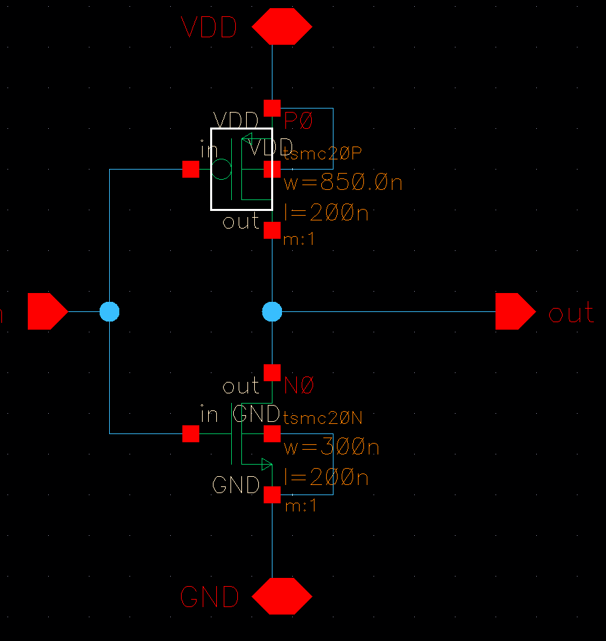

Sizing Used: W_{P} = 850n, W_{N} = 300n

Waveform

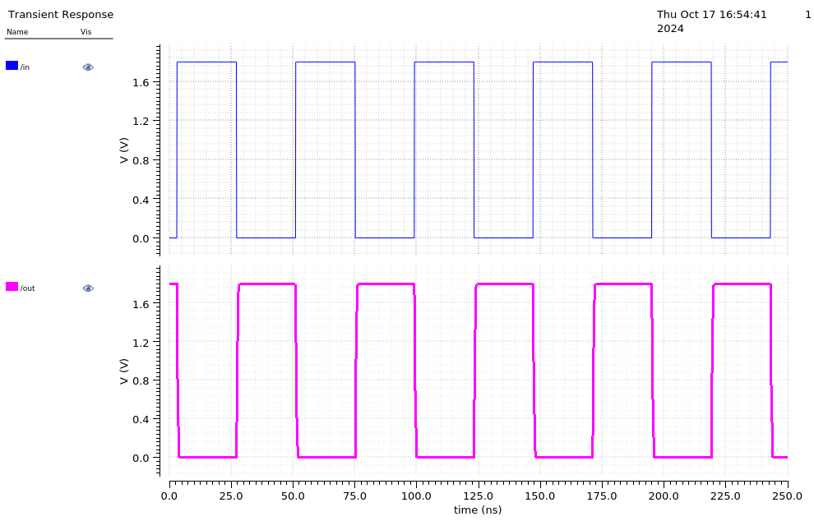

Rising/Falling Delay
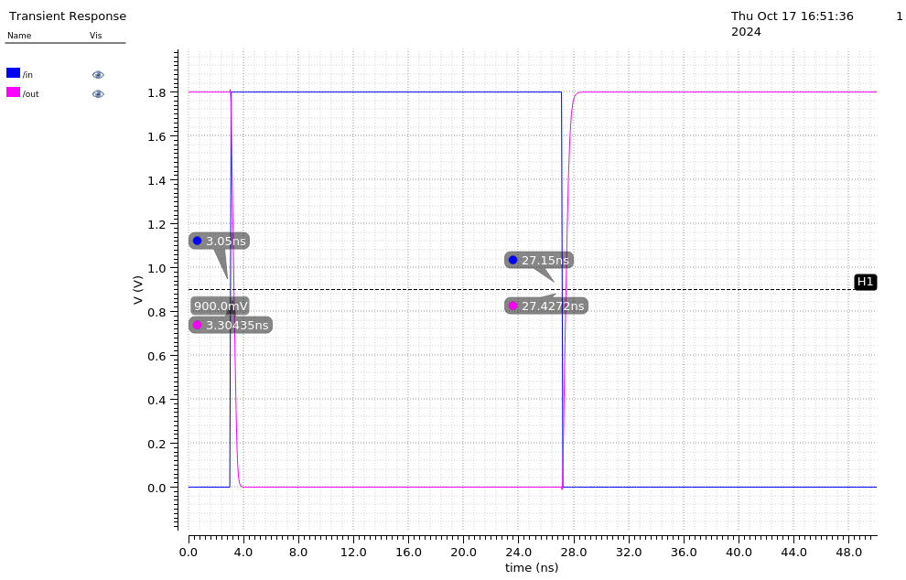

Falling Delay: 3.30435 - 3.05 = 0.25435 ns

Rising Delay: 27.4272 - 27.15 = 0.2772 ns

Error Percentage: (Abs(Rising - Falling) / Min) * 100 = 8.98% < 10% ✅

Power Dissipation

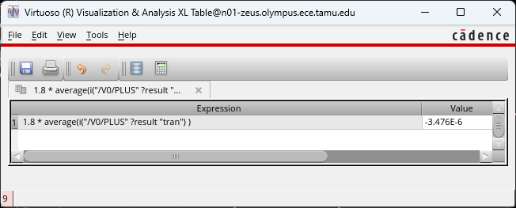

VDD: 3.476 µW

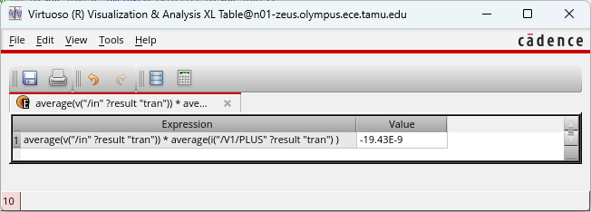

V_Pulse: 19.43 nW

Inverter (Improving Design to Minimize Delay)

Schematic:
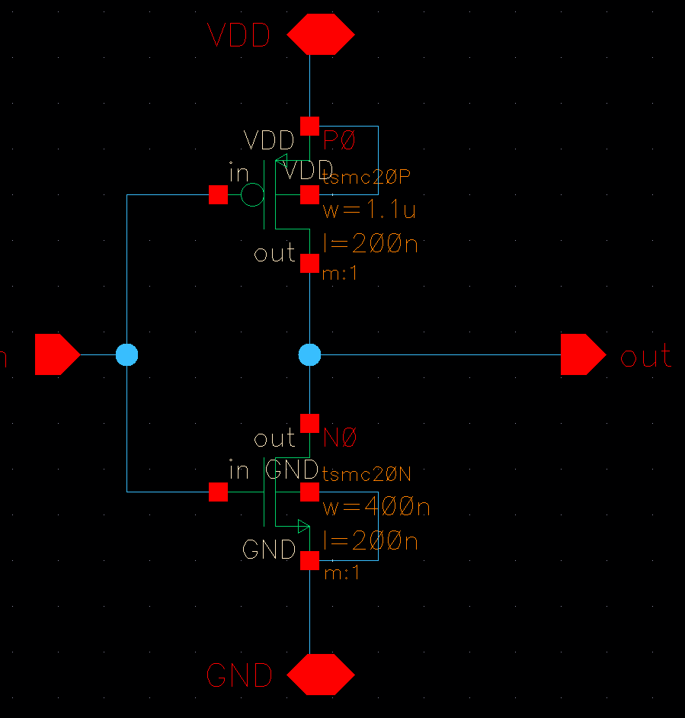

Sizing Used: W_{P} = 1.1µ, W_{N} = 400n

Waveform

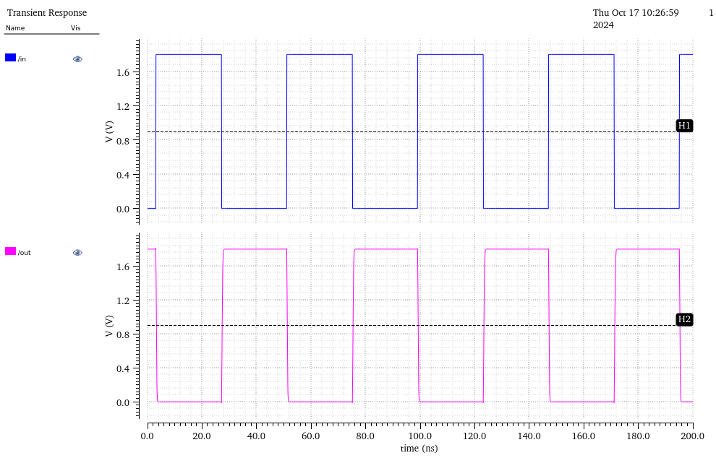

Rising/Falling Delay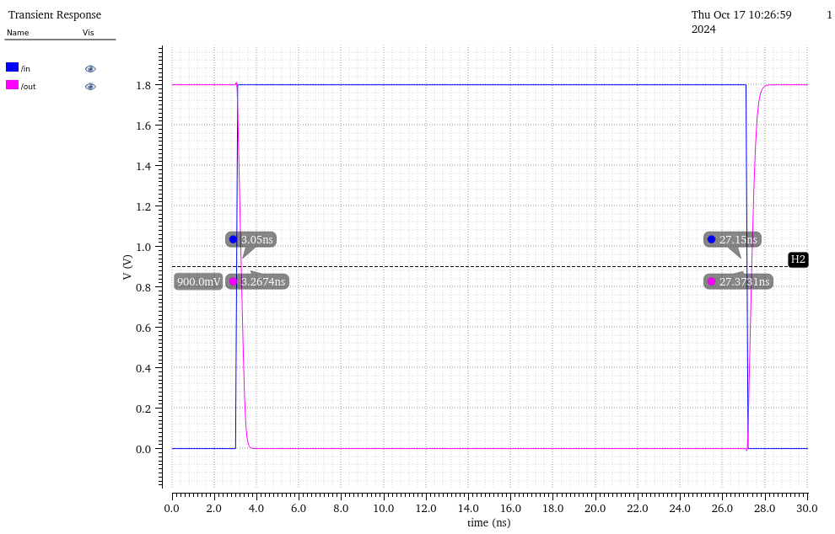

Falling Delay: 3.2674 - 3.05 = 0.2174 ns

Rising Delay: 27.3731 - 27.15 = 0.2231 ns

Error Percentage: (Abs(Rising - Falling) / Min) * 100 = 2.62% < 10% ✅

Power Dissipation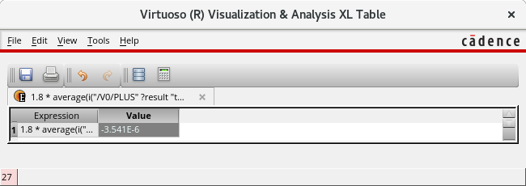

VDD: 3.541 µW

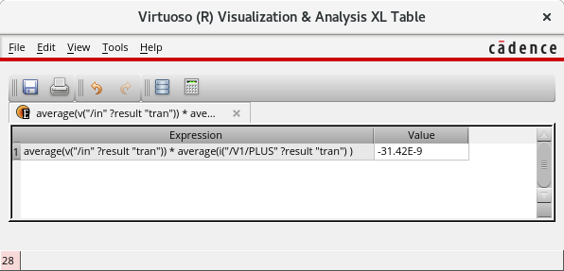

V_Pulse: 31.42 nW

NAND2 (Baseline)

Schematic:
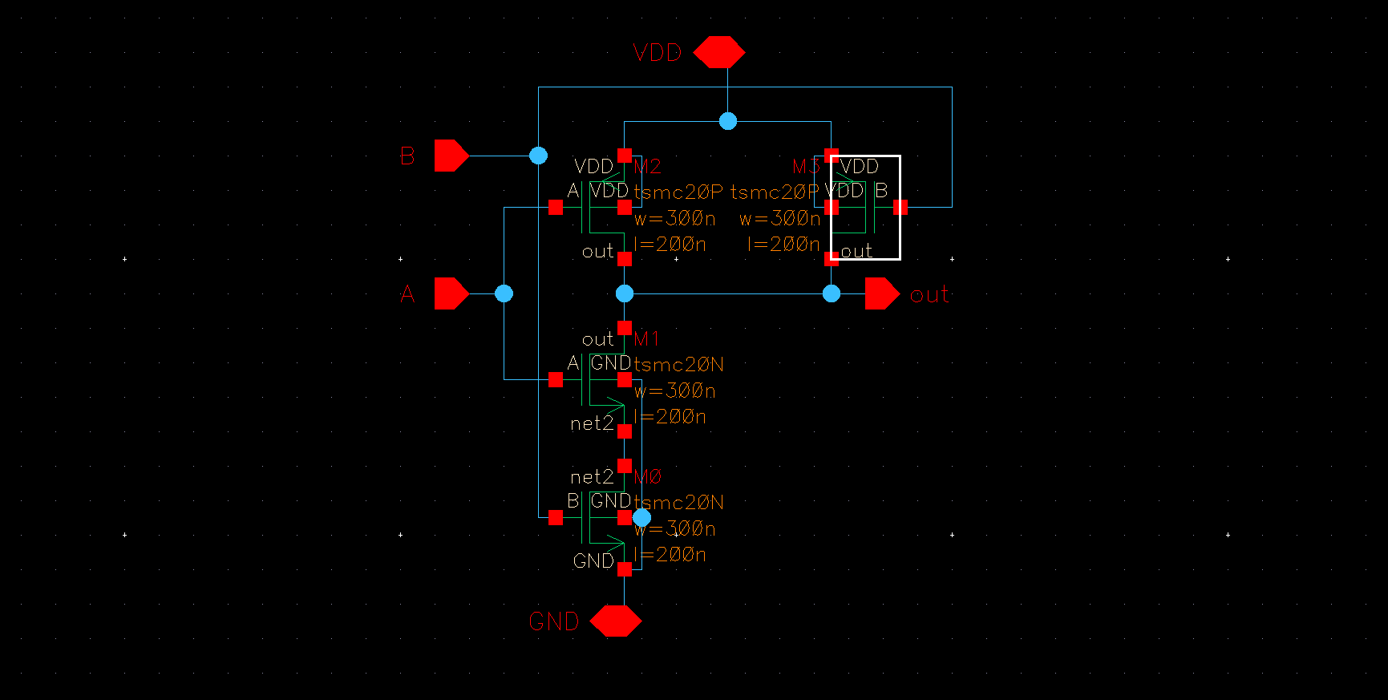

Sizing Used: W_{P} = 300n, W_{N} = 300n

Waveform:

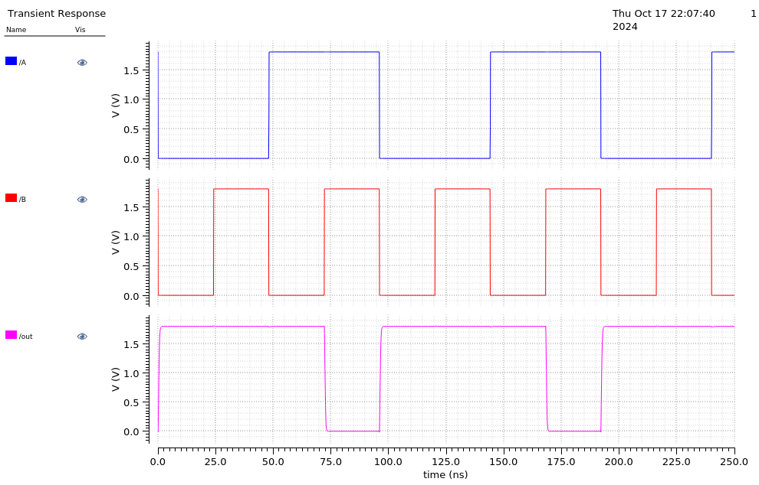

Rising/Falling Delay:

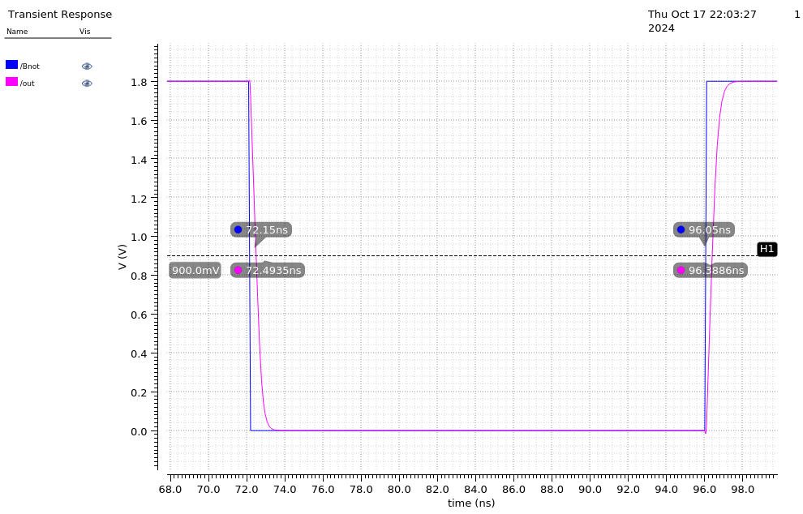

Falling Delay: 72.4935 - 72.15 = 0.3435 ns

Rising Delay: 96.3886 - 96.05 = 0.3386 ns

Error Percentage: (Abs(Rising - Falling) / Min) * 100 = 1.45% < 10% ✅

Power Dissipation

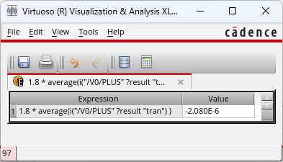

VDD: 2.080 µW

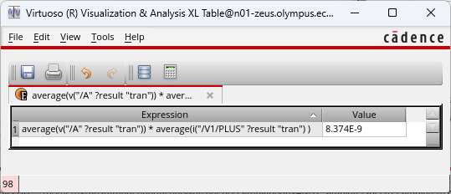

V_Pulse (A): 8.374 nW
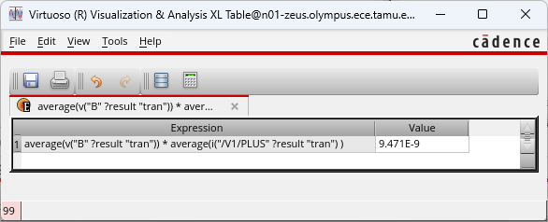

V_Pulse (B): 9.471 nW

NAND2 (Improving Design to Minimize Delay)

Schematic:
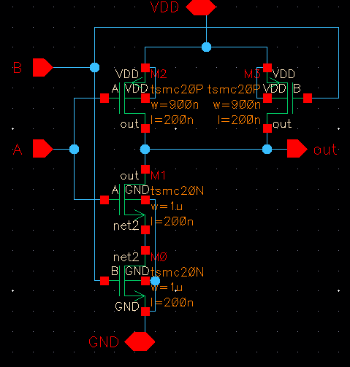

Sizing Used: W_{P} = 900n, W_{N} = 1µ

Waveform

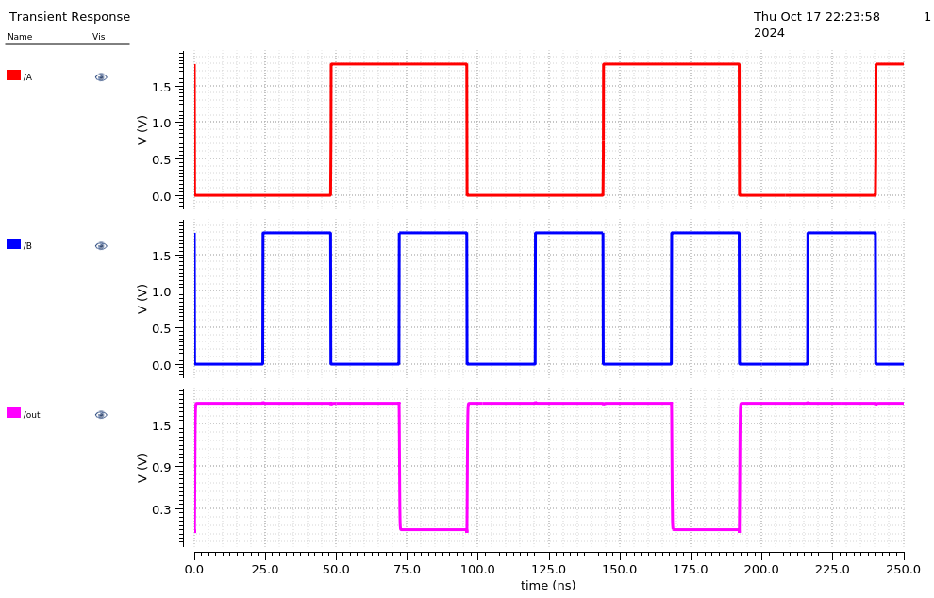

Rising/Falling Delay
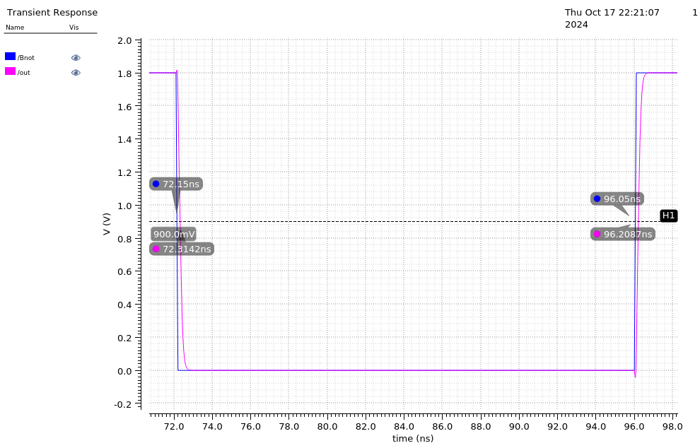

Falling Delay: 72.3142 - 72.15 = 0.1642 ns

Rising Delay: 96.2087 - 96.05 = 0.1587 ns

Error Percentage: (Abs(Rising - Falling) / Min) * 100 = 3.47% < 10% ✅

Power Dissipation

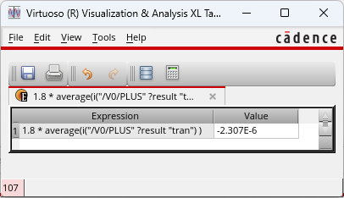

VDD: 2.307 µW

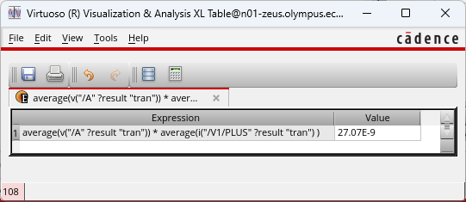

V_Pulse (A): 27.07 nW

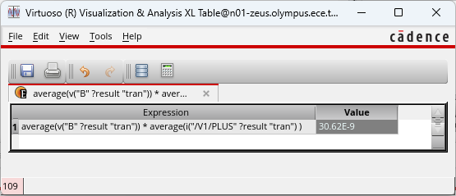

V_Pulse (B): 30.62 nW

XOR (Baseline):

Schematic:

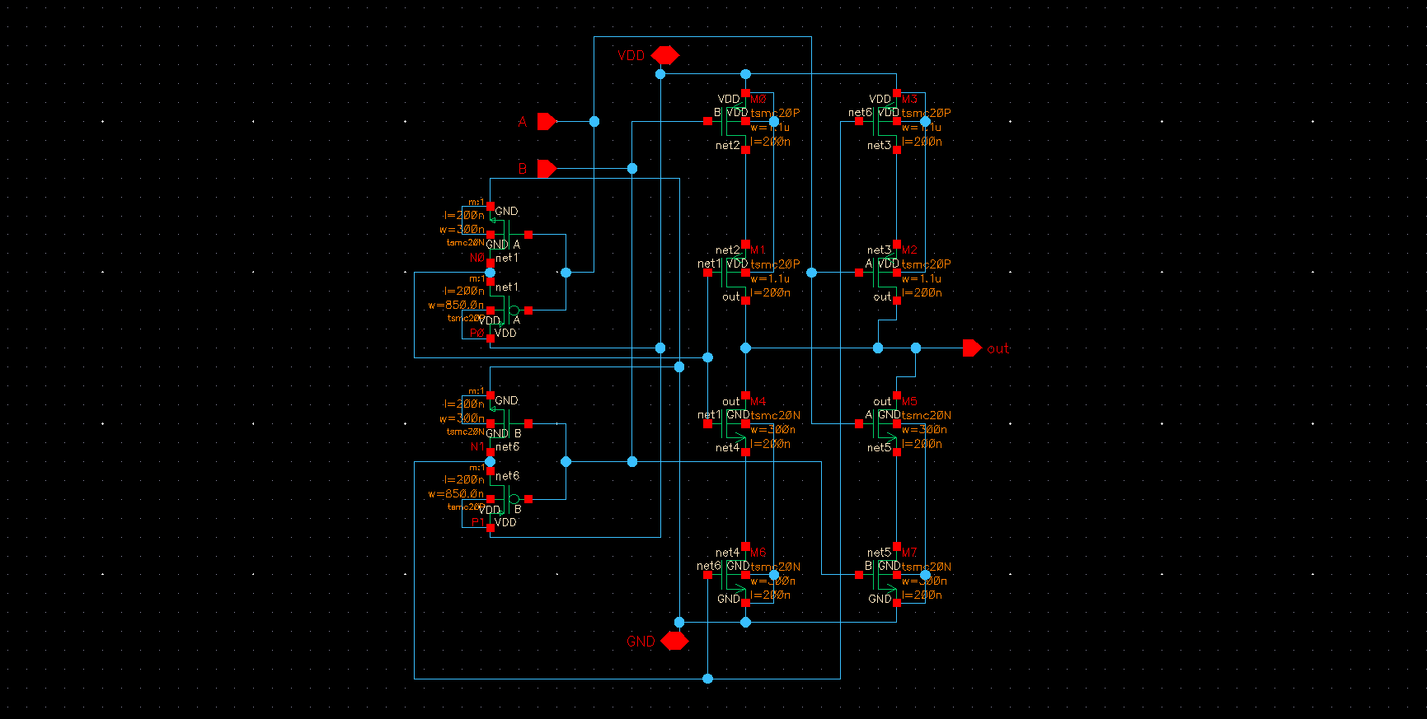

Sizing Used: W_{P} = 1.1µ, W_{N} = 300n.

Also used the baseline sizing for the inverter: W_{P} = 850n, W_{N} = 300n

Waveform:
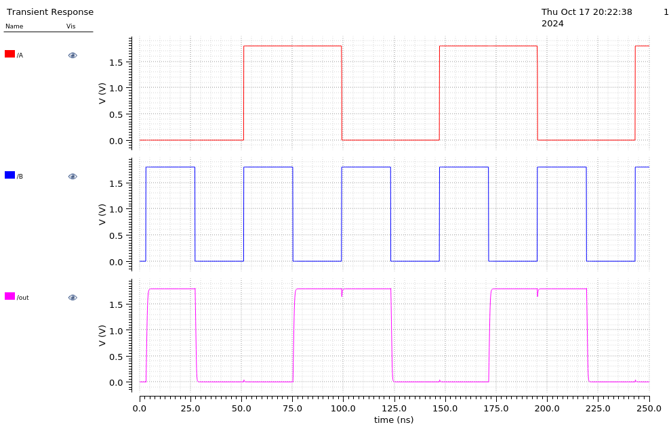

Rising/Falling Delay

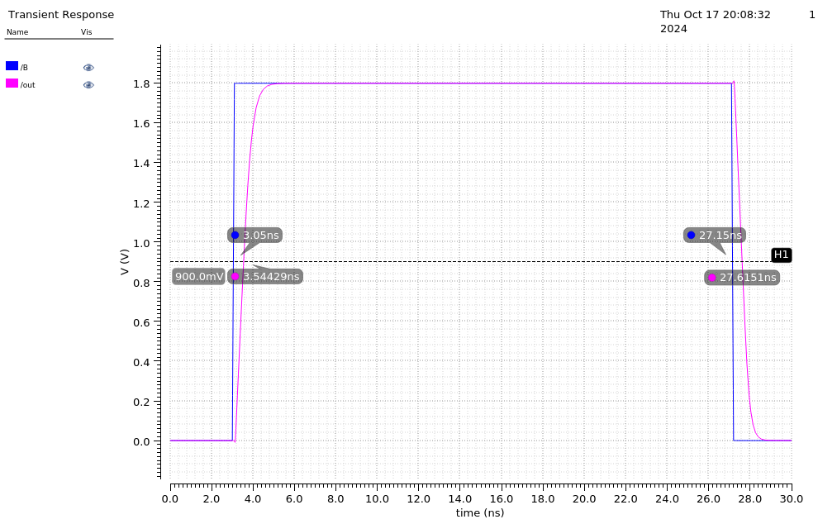

Falling Delay: 27.6151 - 27.15 = 0.49429 ns

Rising Delay: 3.54429 - 3.05 = 0.4651 ns

Error Percentage: (Abs(Rising - Falling) / Min) * 100 = 6.28% < 10% ✅

Power Dissipation
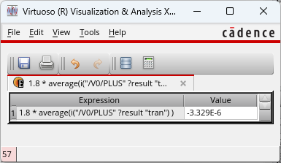

VDD: 3.329 µW

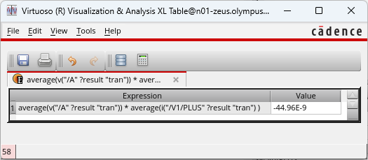

V_Pulse (A): 44.96 nW
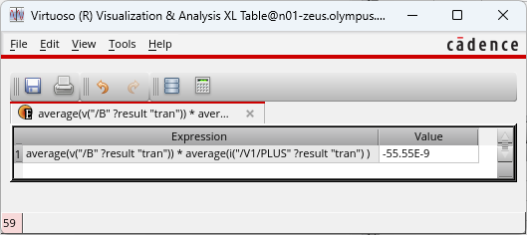

V_Pulse (B): 55.55 nW

XOR (Improving Design to Minimize Delay):

Schematic:

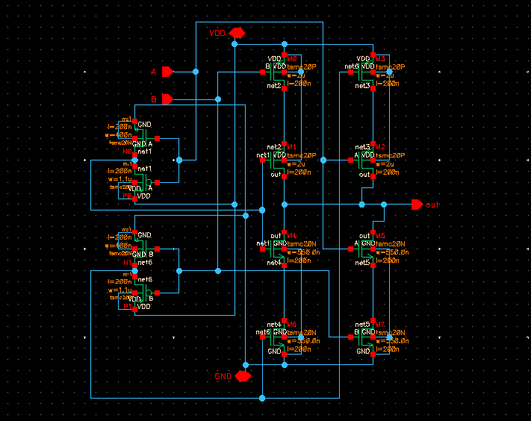

Sizing Used: W_{P} = 2µ, W_{N} = 550n.

I also used the improved sizing for the inverter: W_{P} = 1.1µ, W_{N} = 450n

Waveform:
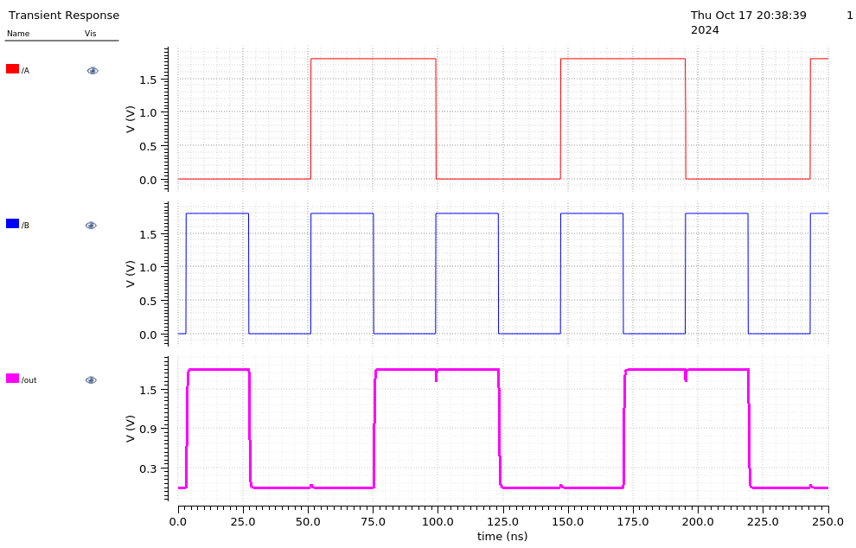

Rising/Falling Delay
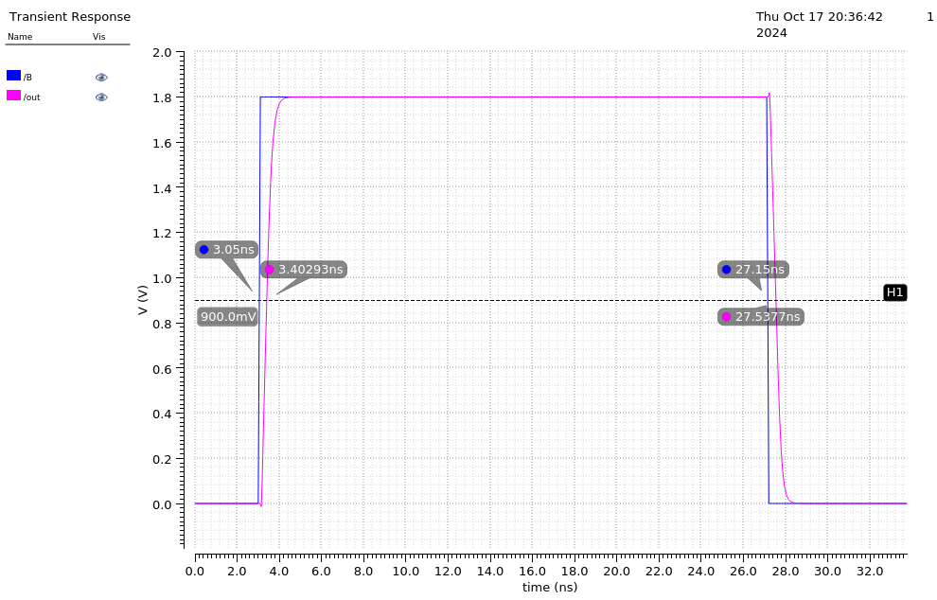

Falling Delay: 27.5377 - 27.15 = 0.3877 ns

Rising Delay: 3.40293 - 3.05 = 0.35293 ns

Error Percentage: (Abs(Rising - Falling) / Min) * 100 = 9.85% < 10% ✅

Power Dissipation
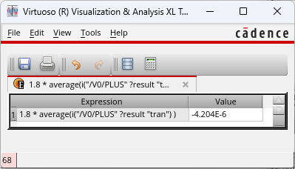

VDD: 4.204 µW

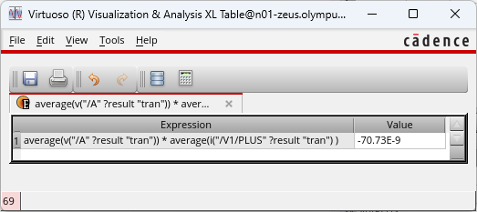

V_Pulse (A): 70.73 nW
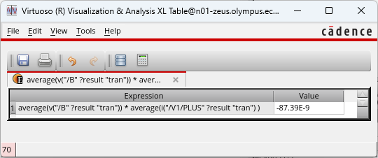

V_Pulse (B): 87.39 nW

1-bit Adder

Schematic:
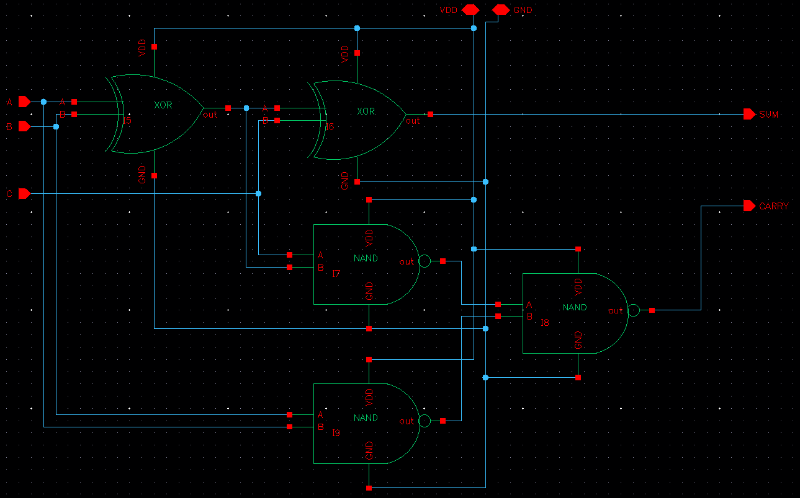

Layout:
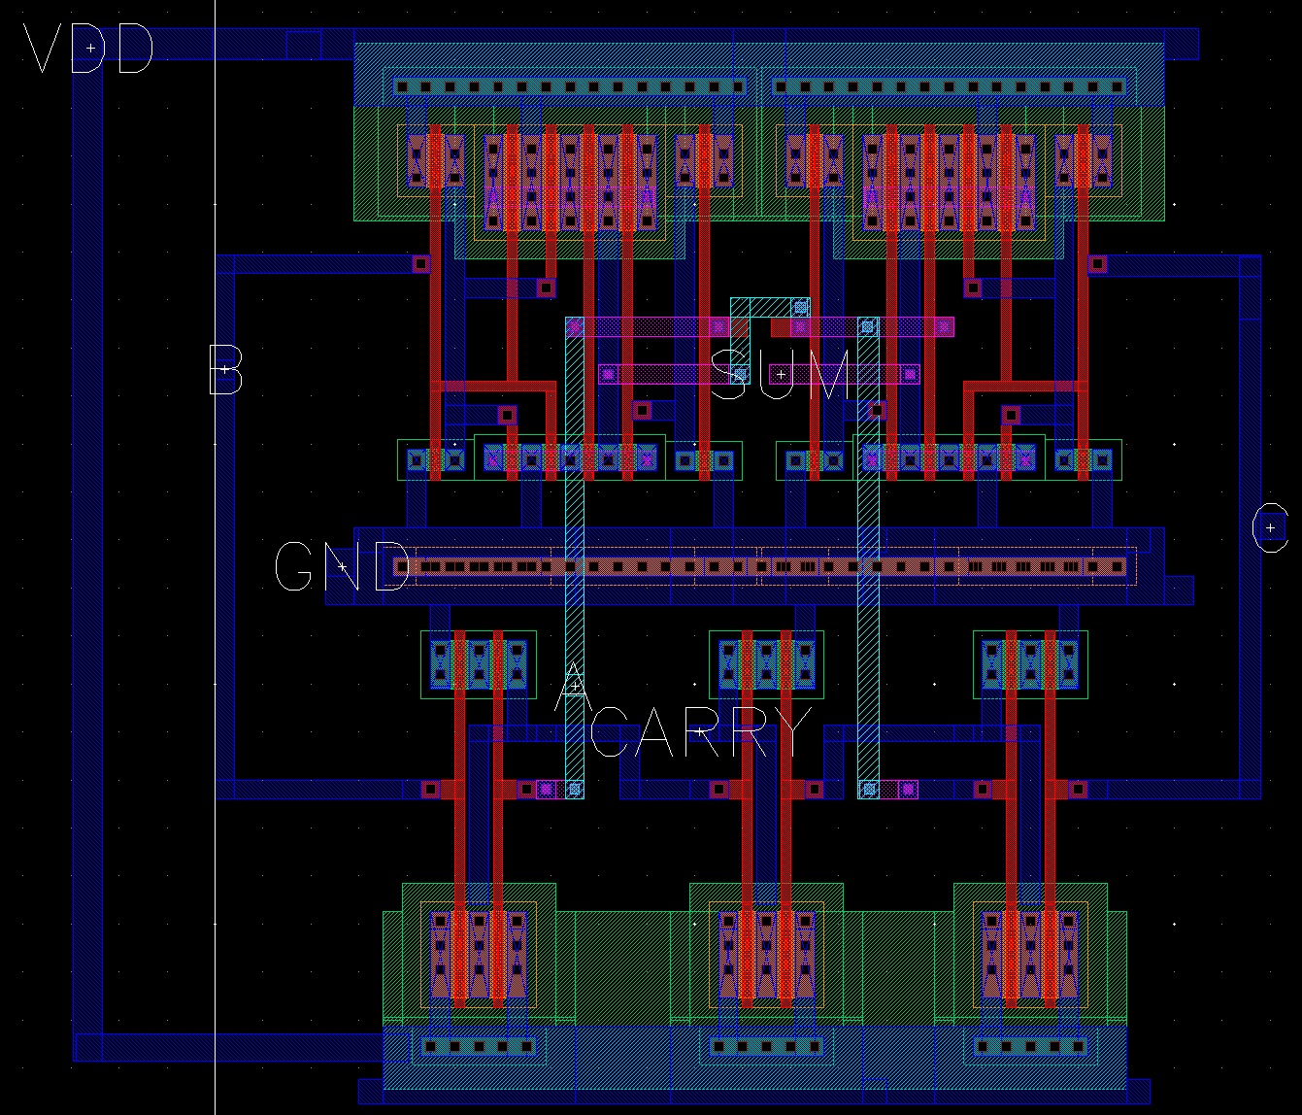

Sizing Used:

Inverter: W_{P} = 1.1µ, W_{N} = 400n
NAND2: W_{P} = 900n, W_{N} = 1µ
XOR: W_{P} = 2µ, W_{N} = 550n.

Waveform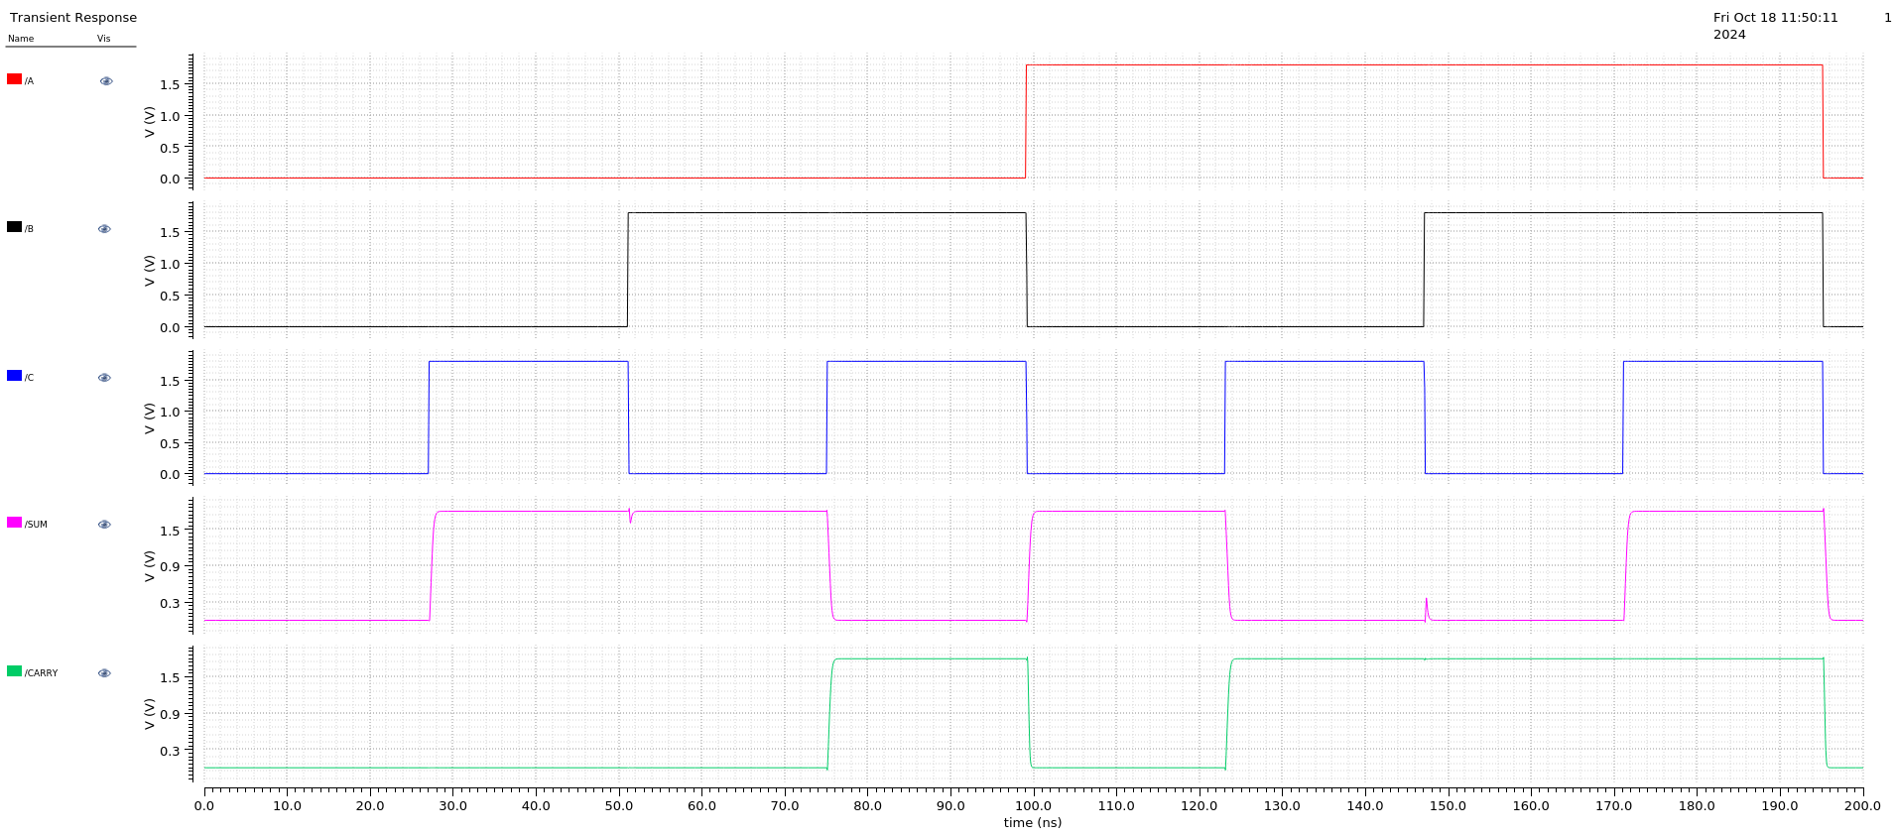

Rising/Falling Delay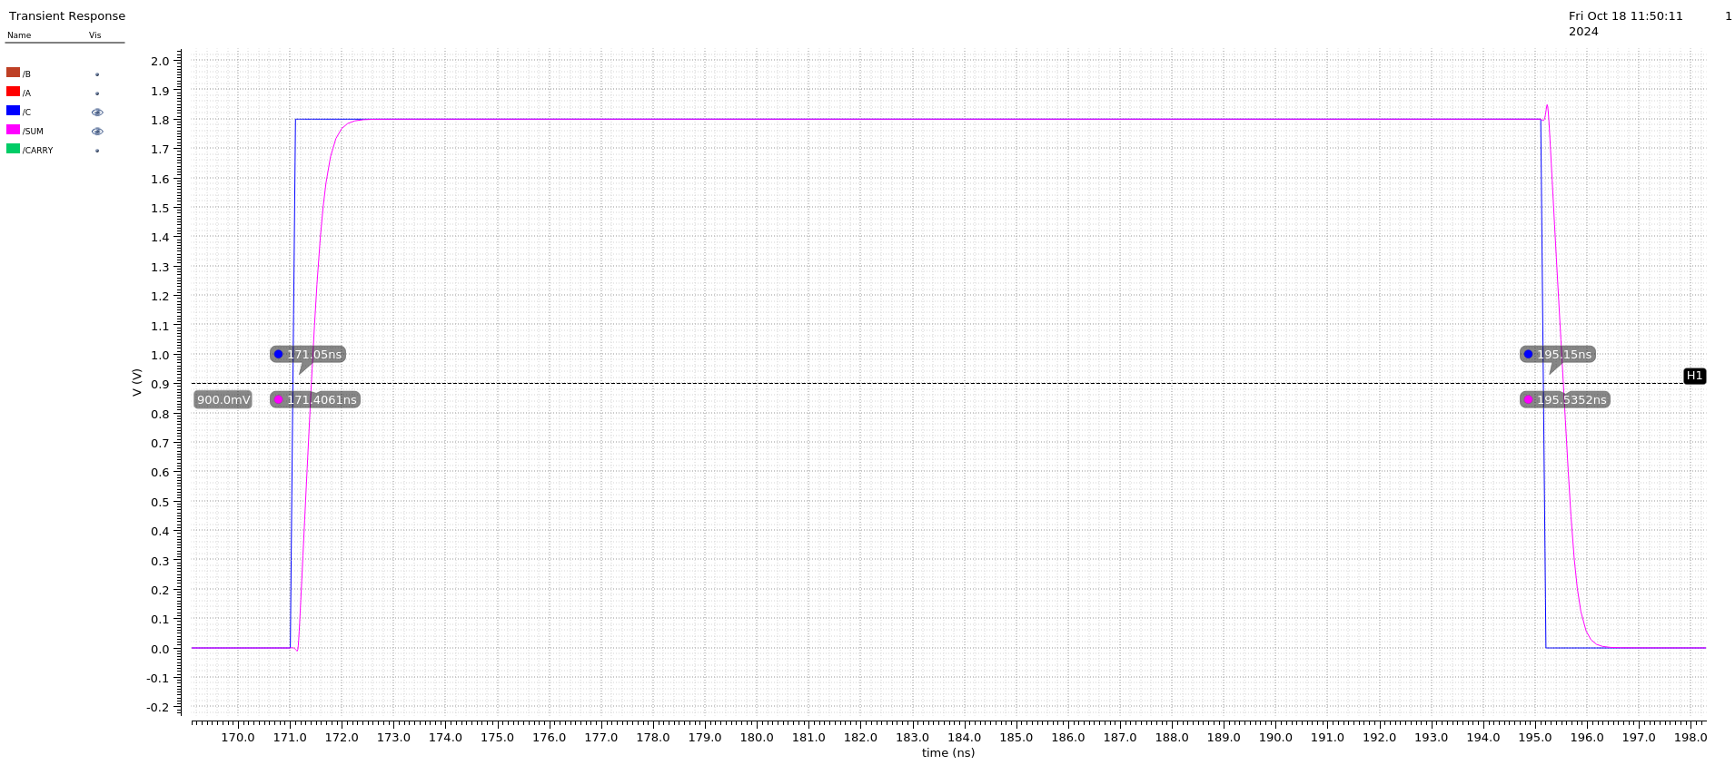

Falling Delay: 195.15 - 195.5352 = 0.3561 ns

Rising Delay: 171.4061 - 171.05 = 0.3852 ns

Error Percentage: (Abs(Rising - Falling) / Min) * 100 = 8.17% < 10% ✅

Power Dissipation
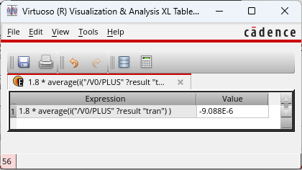
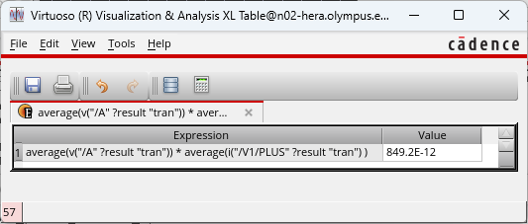
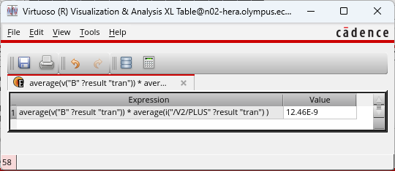
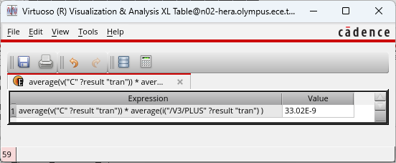

Max Frequency

Testing with 1ns, the output is inconsistent:
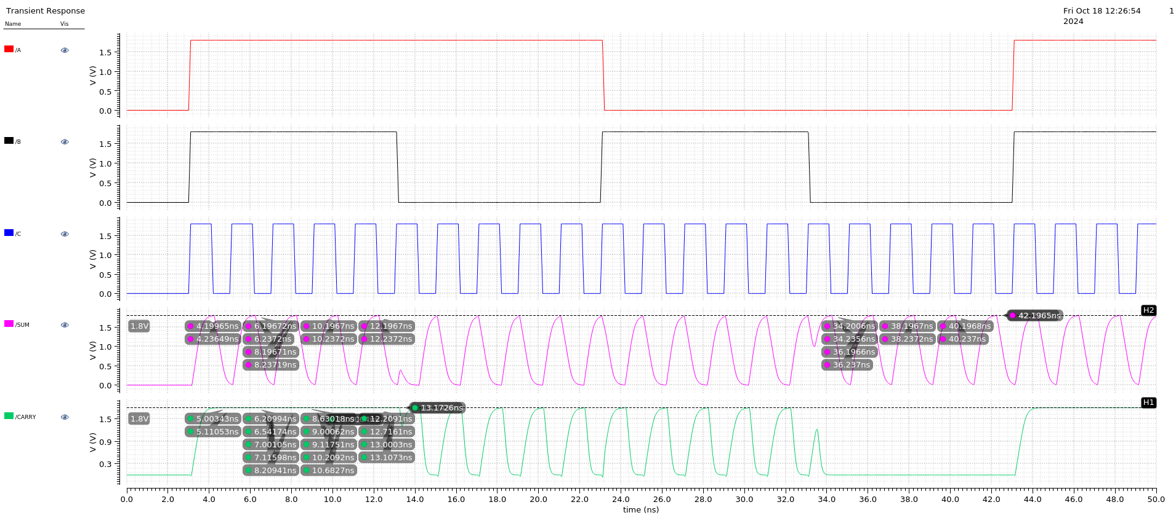

Testing with 2ns, the output is consistent and reaches 1.8V for every transition:
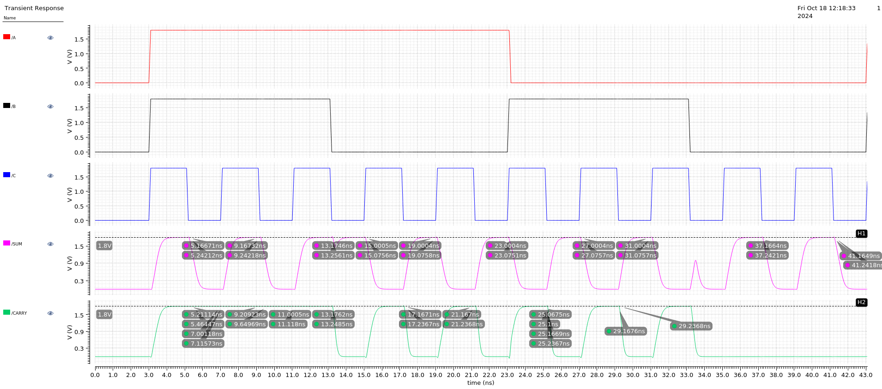

Therefore, max frequency = 1/2ns = 500 MHz

